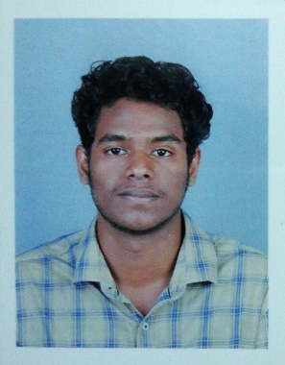

ANANDHU

CONTACT

V

**DOB: 18-11-1999**

LANGUAGES KNOWN:

ENGLISH

MALAYALAM

TAMIL

To seek a dynamic and challenging career in an organization for making positive contribution towards the organization, and to find an environment where I could materialize my professional knowledge and interpersonal skills for mutual benefit of the organization and myself.

SKILLS

**COMMUNICATION SKILLS**

**PROBLEM-SOLVING**

**RESPONSIBILITY**

**TIME MANAGEMENT SKILLS**

EDUCATION

**SSLC**

MTHSS KAPPRASSERY

**HIGHER SECONDARY** in PHYSICAL SCIENCE

MTHSS KAPPRASSERY

**86%**

**64%**

**HOME:** MEKKARATHUNDI HOUSE,

ELAVOOR P.O, ANGAMALY

**EMAIL:** nandhuanandhu91@gmail.com

**PHONE:** +91 9846515837